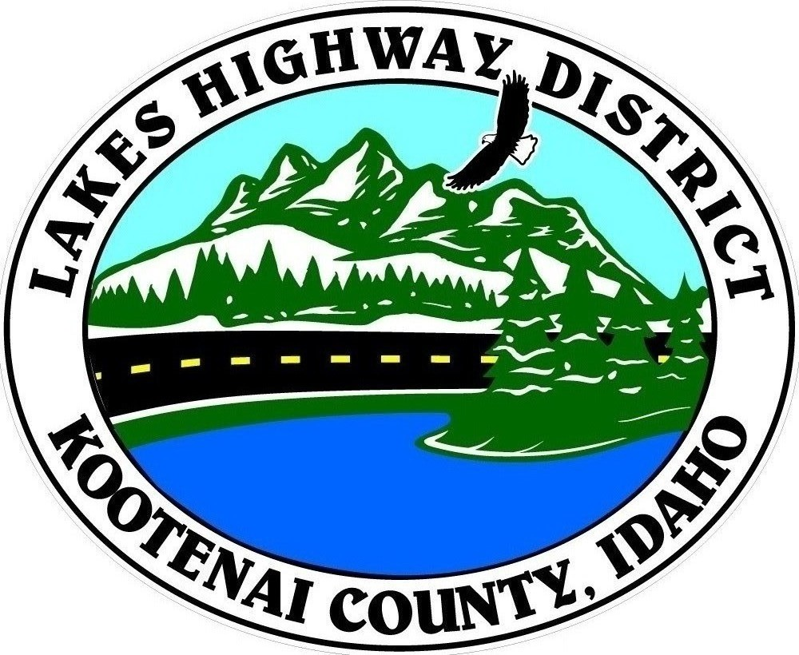
LAKES HIGHWAY DISTRICT
Chairman, Rodney A. Twete, Commissioner District 1
Vice Chairman, Weston E. “Monty” Montgomery, Commissioner District 2
Diane J. Fountain, Commissioner District 3

BOARD MEETING AGENDA

January 17, 2022 - 5:30 p.m.
11341 N. Ramsey Road
Hayden, Idaho 83835

1. Call Meeting to Order
2. Pledge of Allegiance
3. Approve January 17, 2022 Meeting Agenda (Action Item)
4. Approve December 16, 2021 Special Meeting Minutes (Action Item)
5. Approve January 12, 2022 Special Meeting Minutes (Action Item)
6. Administrative Matters
a. Approve Financial Reports – (Action Item)
7. Public Comment – this section is reserved for citizens wishing to address the Board regarding District related issue. Comments are limited to two (2) minutes per person. Idaho Law prohibits Board action on items brought under this section.

8. Old Business
9. Current Business
a. McLaren Brothers Plat Review (Action Item)
b. Wapiti Ridge Plat Review (Action Item)
c. Rau Estates Plat Review (Action Item)
d. Bohn Estates Plat Review (Action Item)
e. Bohn Estates 1st Addition Plat Review (Action Item)
f. 2024 LHSIP Grant Application (Action Item)
g. Public Hearing – Validation of Viewer Report #30 (Action Item)
h. Intersection Operational Analysis – Ramsey @ Scarcello (Action Item)
i. Avondale Irrigation Easement – Lancaster Road Property (Action Item)
j. City of Hayden Facilities Transfer MOU (Action Item)
10. Executive Session
a. Idaho Code §74-206 (1) (c ) (Action Item)
11. Upcoming Meetings
a. Lakes Highway District Meeting – February 7, 2022 – 5:30 p.m.
12. Commissioner Comments
13. ADJOURN

Any person needing special accommodations to participate in the above noticed meeting should contact Lakes Highway District five (5) days prior to the meeting at (208)772-7527 or 11341 N. Ramsey Road, Hayden, Idaho 83835.

