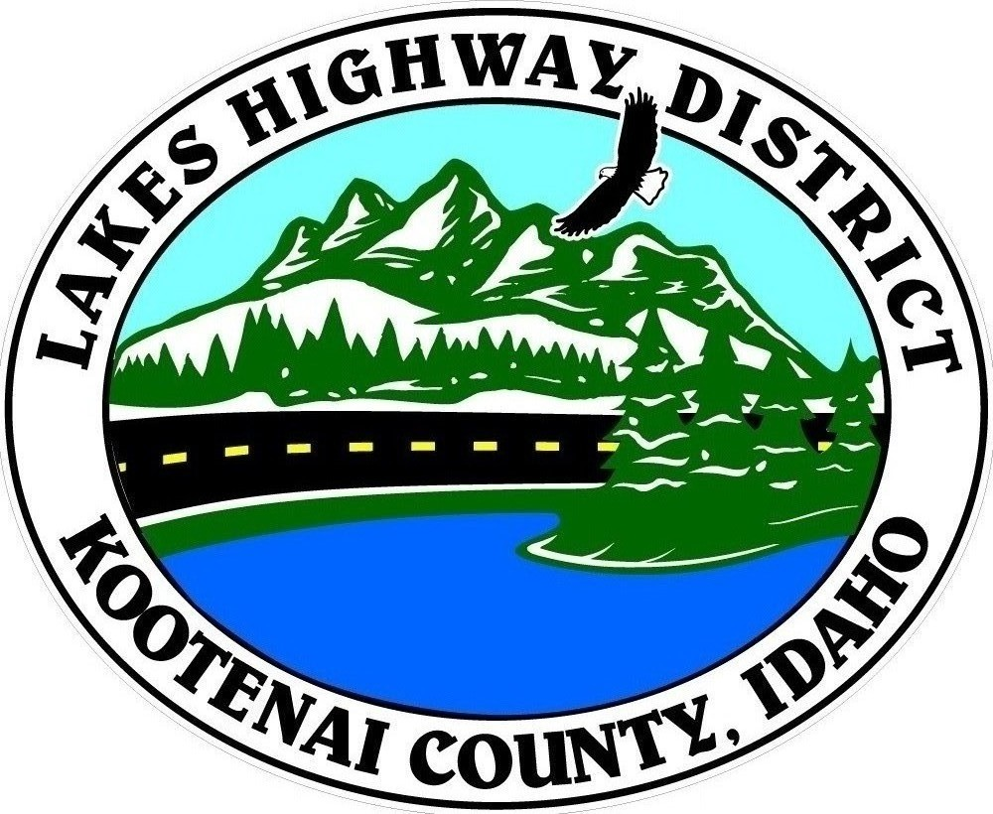
LAKES HIGHWAY DISTRICT
Chairman, Rodney A. Twete, Commissioner District 1
Vice Chairman, Weston E. “Monty” Montgomery, Commissioner District 2
Diane J. Fountain, Commissioner District 3

BOARD MEETING AGENDA

May 1, 2023 - 5:30 p.m.
11341 N. Ramsey Road
Hayden, Idaho 83835

1. Call Meeting to Order
2. Pledge of Allegiance
3. Approve May 1, 2023 Meeting Agenda (Action Item)
4. Approve April 3, 2023 Regular Meeting Minutes (Action Item)
5. Administrative Matters
a. Approve Financial Reports – (Action Item)
6. Public Comment – this section is reserved for citizens wishing to address the Board regarding District related issues. Comments are limited to two (2) minutes per person. Idaho Law prohibits Board action on items brought under this section.

7. Old Business
a. Lakestone Estates (Discussion Item)
b. Set Site Visit for Kootenai County Validation (Action Item)
c. Consider Award of Pavement Markings Bid (Action Item)
d. Brunner Road Grade Separation - Right-of-Way Scope of Work (Action Item)

8. Current Business
a. Public Hearing – Abandonment & Vacation (Action Item)
b. Laney Acres Plat Review (Action Item)
c. Treeline Two Plat Review (Action Item)
d. Bunco Base Camp Special Permit Notice (Action Item)
e. Pur-Pos Access Improvement Plan Review (Action Item)
f. Letter of Support – Intermax Network (Action Item)

9. Executive Session
a. Idaho Code §74-206 (1) (f) (Action Item)

10. Upcoming Meetings
a. Lakes Highway District Meeting – May15, 2023 – 5:30 p.m.

11. Commissioner Comments

12. ADJOURN

Any person needing special accommodations to participate in the above noticed meeting should contact Lakes Highway District five (5) days prior to the meeting at (208)772-7527 or 11341 N. Ramsey Road, Hayden, Idaho 83835.

