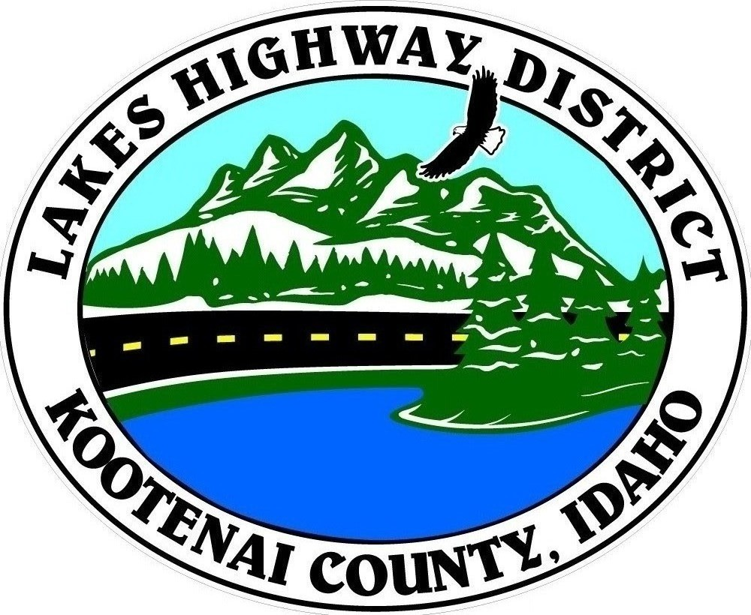
LAKES HIGHWAY DISTRICT
Chairman, Rodney A. Twete, Commissioner District 1
Vice Chairman, Weston E. “Monty” Montgomery, Commissioner District 2
Diane J. Fountain, Commissioner District 3

BOARD MEETING AGENDA

January 9, 2023 - 5:30 p.m.
11341 N. Ramsey Road
Hayden, Idaho 83835

1. Call Meeting to Order
2. Pledge of Allegiance
3. Approve January 9, 2023 Meeting Agenda (Action Item)
4. Approve December 19, 2022 Regular Meeting Minutes (Action Item)
5. Public Comment – this section is reserved for citizens wishing to address the Board regarding District related issue. Comments are limited to two (2) minutes per person. Idaho Law prohibits Board action on items brought under this section.

6. Old Business
a. Redspire Road Abandonment & Vacation (Action Item)
b. Garwood Facility Update (Action Item)
7. Current Business
a. Public Hearing – Spokane Valley Commercial Orchards Validation (Action Item)
b. Public Hearing – Lake Park Acre Tracts–Abandonment & Vacation (Action Item)
c. IAHD Annual 2023 Dues (Action Item)
d. 2023 Legal Assistance Program (Action Item)
e. Rimrock Road Approach Appeal Fee & Culvert (Action Item)

8. Executive Session
a.
9. Upcoming Meetings
a. Lakes Highway District Meeting – January 23, 2022 – 5:30 p.m.
10. Commissioner Comments
11. ADJOURN

Any person needing special accommodations to participate in the above noticed meeting should contact Lakes Highway District five (5) days prior to the meeting at (208)772-7527 or 11341 N. Ramsey Road, Hayden, Idaho 83835.

