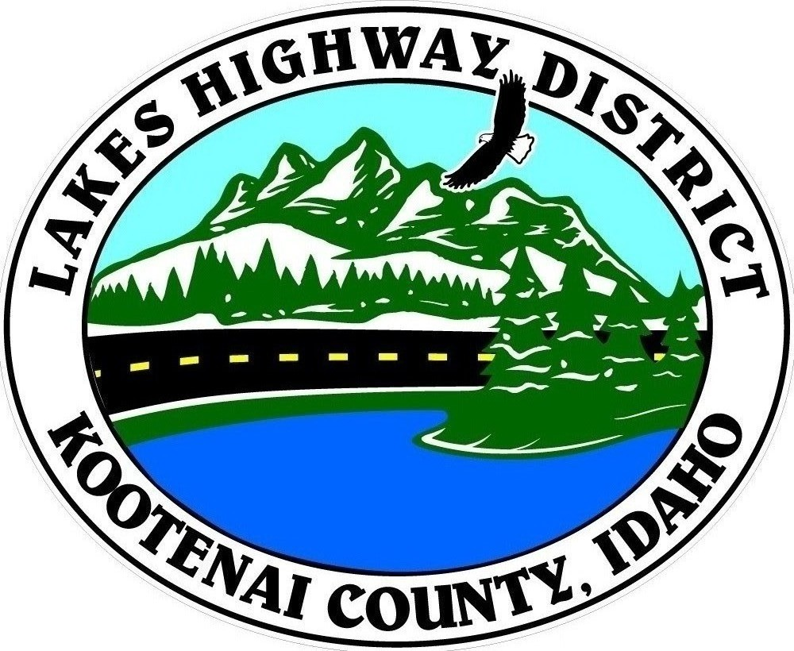
LAKES HIGHWAY DISTRICT
Chairman, Rodney A. Twete, Commissioner District 1
Vice Chairman, Weston E. “Monty” Montgomery, Commissioner District 2
Diane J. Fountain, Commissioner District 3

BOARD MEETING AGENDA

January 23, 2023, 2022 - 5:30 p.m.
11341 N. Ramsey Road
Hayden, Idaho 83835

1. Call Meeting to Order
2. Pledge of Allegiance
3. Approve January 23, 2023 Meeting Agenda (Action Item)
4. Approve January 9, 2023, Regular Meeting Minutes (Action Item)
5. Approve January 11, 2023 Special Meeting Minutes (Action Item)
6. Administrative Matters
a. Approve Financial Reports – (Action Item)
7. Public Comment – this section is reserved for citizens wishing to address the Board regarding District related issue. Comments are limited to two (2) minutes per person. Idaho Law prohibits Board action on items brought under this section.

8. Old Business
a. Public Hearing Continuation–Spokane Valley Commercial Orchards (Action Item)
b. Garwood Facility Survey Amendment (Action Item)
c. Garwood Facility, Design, Bid and Construction Architectural and Engineering Fees Contract Proposal (Action Item)

9. Current Business
a. Bennett Acres Variance Request (Action Item)
b.
c.
d.
e.
10. Executive Session
a.
11. Upcoming Meetings
a. Lakes Highway District Meeting – February 6, 2023 – 5:30 p.m.

12. Commissioner Comments

13. ADJOURN

Any person needing special accommodations to participate in the above noticed meeting should contact Lakes Highway District five (5) days prior to the meeting at (208)772-7527 or 11341 N. Ramsey Road, Hayden, Idaho 83835.

