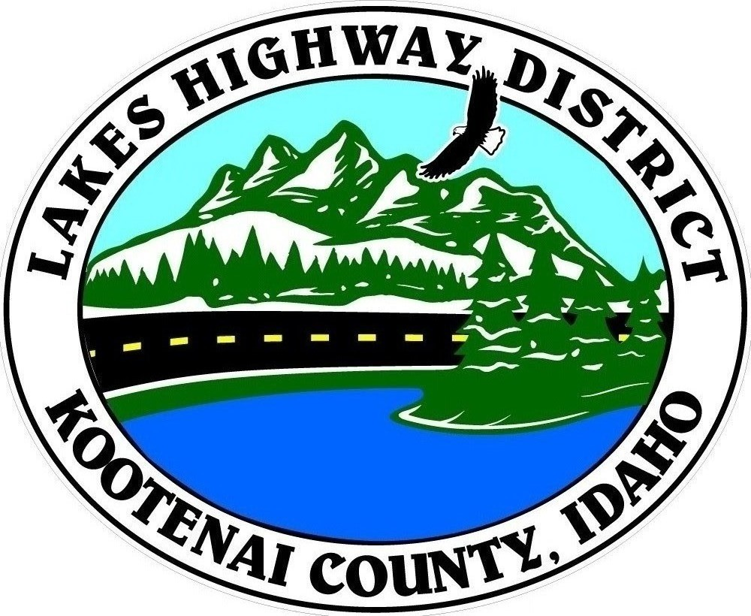
LAKES HIGHWAY DISTRICT
Chairman, Rodney A. Twete, Commissioner District 1
Weston E. “Monty” Montgomery, Commissioner District 2
Vice Chairman, Steven R. Adams, Commissioner District 3

BOARD MEETING AGENDA

July 17, 2023 - 5:30 p.m.
11341 N. Ramsey Road
Hayden, Idaho 83835

1. Call Meeting to Order
2. Pledge of Allegiance
3. Approve July 17, 2023 Meeting Agenda (Action Item)
4. Public Comment – this section is reserved for citizens wishing to address the Board regarding District related issues. Comments are limited to two (2) minutes per person. Idaho Law prohibits Board action on items brought under this section.

5. Consent Agenda (Action Item)
a. Approve Financial Reports
b. Approve July 3, 2023, Regular Meeting Minutes
c. MIN23-0009 Bohn Estates Second Addition Plat Review

6. Old Business
a. Reconsider selling PU-22 & PU-27 & TR-130 (Action Item)

7. Current Business
a. FY2021-2022 Audit Presentation (Action Item)
b. MSP23-0001 Nottingham Meadows Plat Review (Action Item)
c. Set Public Hearing – Mailhot Vacation & Abandonment (Action Item)
d. Cape Horn Road Walls 4&5 Change Order (Action Item)
e. Century West Engineering - Development Review Request (Action Item)

8. Executive Session
a. I.C. §74-206(1) (b), (f) (Action Item)
9. Upcoming Meetings
a. Lakes Highway District Meeting – August 7, 2023 – 5:30 p.m.

10. Commissioner Comments

11. ADJOURN

Any person needing special accommodations to participate in the above noticed meeting should contact Lakes Highway District five (5) days prior to the meeting at (208)772-7527 or 11341 N. Ramsey Road, Hayden, Idaho 83835.

