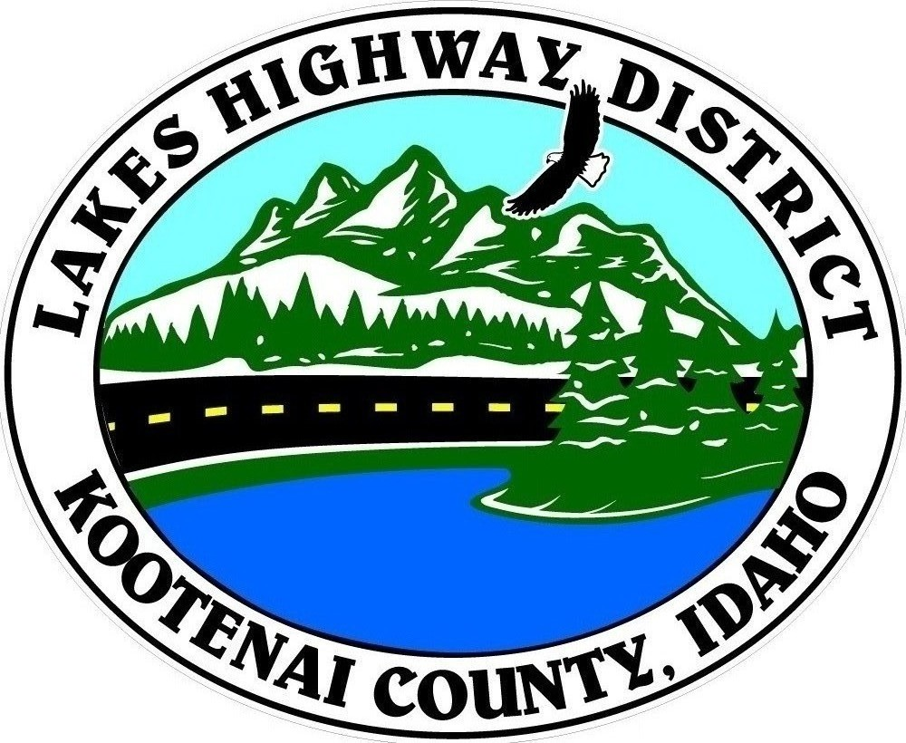
LAKES HIGHWAY DISTRICT
Chairman, Rodney A. Twete, Commissioner District 1
Weston E. “Monty” Montgomery, Commissioner District 2
Vice Chairman, Steven R. Adams, Commissioner District 3

BOARD MEETING AGENDA
November 6, 2023 - 5:30 p.m.
11341 N. Ramsey Road
Hayden, Idaho 83835

1. Call Meeting to Order
2. Pledge of Allegiance
3. Approve November 6, 2023 Meeting Agenda (Action Item)
4. Public Comment – this section is reserved for citizens wishing to address the Board regarding District related issues. Comments are limited to two (2) minutes per person. Idaho Law prohibits Board action on items brought under this section.

5. Consent Agenda (Action Item)
a. Approve October 12, 2023 Special Meeting Minutes
b. Approve October 16, 2023 Regular Meeting Minutes

6. Old Business –
a. Re-convene Public Hearing – Mailhot Abandonment & Vacation (Action Item)
b. Re-convene Public Hearing – 5th Avenue Site Validation (Action Item)
c. 2024 Road Safety Projects (Action Item)

7. Current Business
a. Resolution 2023-14 Road Acceptance (Action Item)
b. 2024 Heath Insurance (Action Item)
c. 2024 De-Icer Chemical Contract (Action Item)
d. Thriving Communities Grant (Action Item)
e. Pay Application #2 – Garwood Facility (Action Item)

8. Executive Session
a. Idaho Code §74-206 (1) (i) (Action Item)

10. Upcoming Meetings
a. Lakes Highway District Meeting – November 20, 2023 – 5:30 p.m.

11. Commissioner Comments

12. ADJOURN

Any person needing special accommodations to participate in the above noticed meeting should contact Lakes Highway District five (5) days prior to the meeting at (208)772-7527 or 11341 N. Ramsey Road, Hayden, Idaho 83835.

