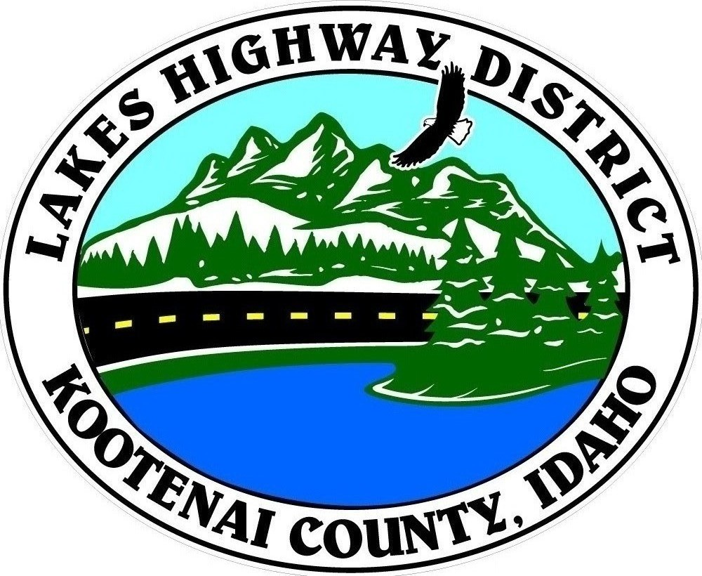
LAKES HIGHWAY DISTRICT
Chairman, Rodney A. Twete, Commissioner District 1
Weston E. “Monty” Montgomery, Commissioner District 2
Vice Chairman, Steven R. Adams, Commissioner District 3

BOARD MEETING AGENDA

August 7, 2023, - 5:30 p.m.
11341 N. Ramsey Road
Hayden, Idaho 83835

DUE TO LACK OF AGENDA ITEMS, THE AUGUST 7, 2023 REGULAR SCHEDULED MEETING OF THE LAKES HIGHWAY DISTRICT BOARD OF COMMISSIONERS HAS BEEN CANCELLED.

THE NEXT REGULAR BOARD MEETING IS AUGUST 28, 2023 AT 5:30 P.M.

