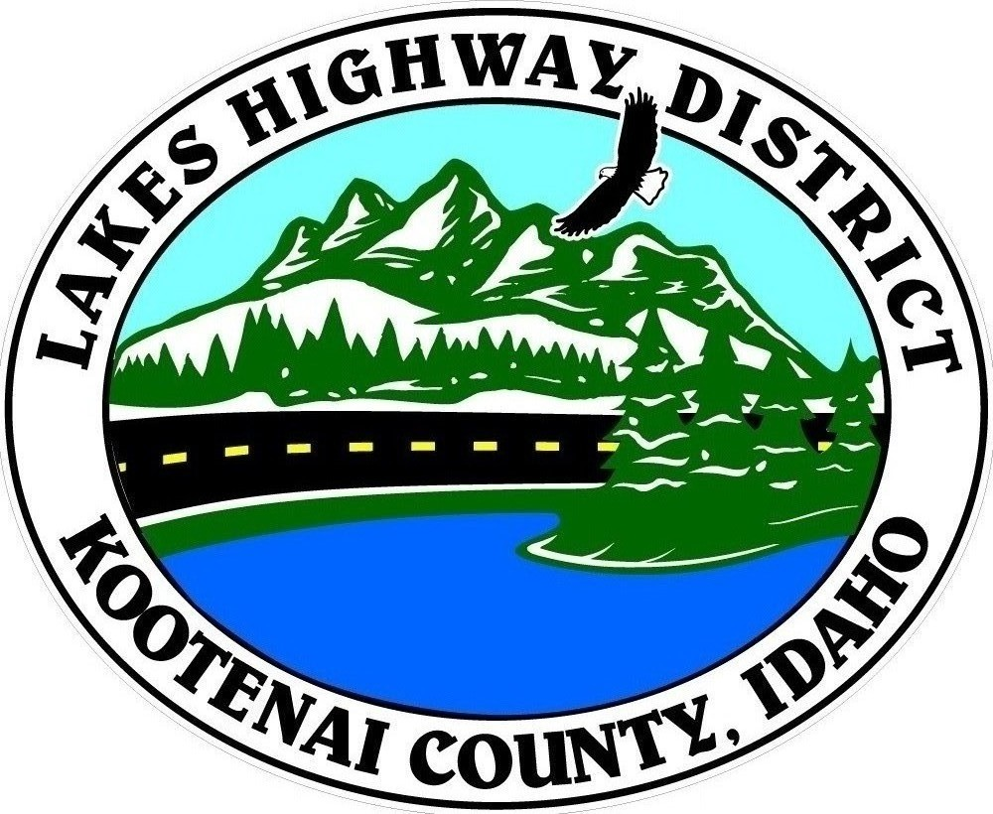
LAKES HIGHWAY DISTRICT
Chairman, Rodney A. Twete, Commissioner District 1
Vice Chairman, Weston E. “Monty” Montgomery, Commissioner District 2
Diane Fountain, Commissioner District 3

WORKSHOP AGENDA
July 28, 2022 @ 8:00 a.m.
11341 N. Ramsey Road
Hayden, Idaho 83835

1. Pledge of Allegiance
2. Current Business
a. 2022-2023 Budget
b.
3. Adjournment

Any person needing special accommodations to participate in the above noticed workshop should contact Lakes Highway District five (5) days prior to the workshop at (208)772-7527 or 11341 N. Ramsey Road, Hayden, Idaho 83835.

