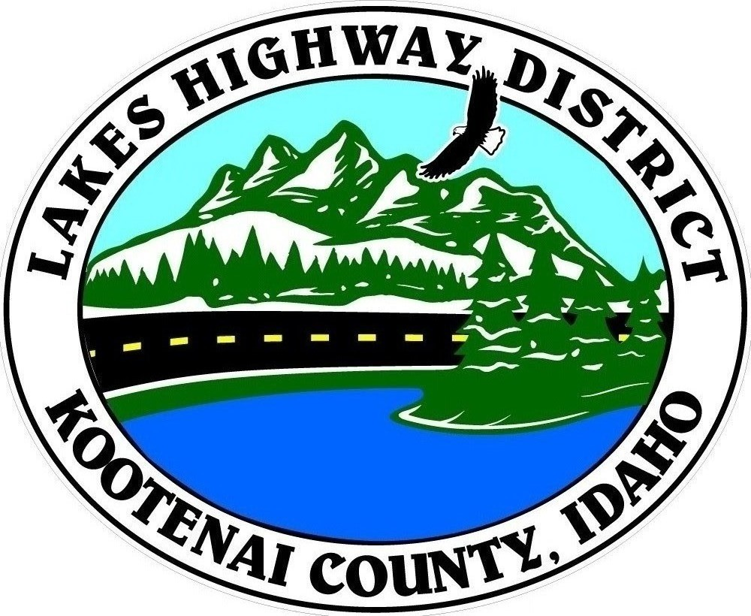
LAKES HIGHWAY DISTRICT
Chairman, Rodney A. Twete, Commissioner District 1
Vice Chairman, Weston E. “Monty” Montgomery, Commissioner District 2
Diane J. Fountain, Commissioner District 3

BOARD MEETING AGENDA

September 19, 2022 - 5:30 p.m.
11341 N. Ramsey Road
Hayden, Idaho 83835

1. Call Meeting to Order
2. Pledge of Allegiance
3. Approve September 19, 2022 Meeting Agenda (Action Item)
4. Approve August 29, 2022 Regular Meeting Minutes (Action Item)
5. Administrative Matters
a. Approve Financial Reports – (Action Item)
6. Public Comment – this section is reserved for citizens wishing to address the Board regarding District related issue. Comments are limited to two (2) minutes per person. Idaho Law prohibits Board action on items brought under this section.
7. Old Business
a. Hoodoo Valley South 4th Addition (Action Item)
8. Current Business
a. Public Hearing – Right-of-Way Validation - Spokane Valley Commercial Orchards (Action Item)
b. Administrative Appeal – Lazar Gate Encroachment (Action Item)
c. Chilco Road Turn Lane Plans – LME 8-11th Additions (Action Item)
d. Boss Tracts Plat Review (Action Item)
e. Levi Flats Plat Review (Action Item)
f. King Estates Plat Review (Action Item)
g. Harris Estates Plat Review (Action Item)
h. North Hayden Storage CUP (Action Item)
i. Associated Highway District Standards Turn Lane Addendum (Action Item)
j De-Icer Quote (Action Item)
k. Salt Quote (Action Item)
l. City of Hayden MOU, Building Transfer Exhibit A (Action Item)
m. Traffic Counter Purchases (Action Item)
n. Request for Proposals – Audit Services (Action Item)
o. Garwood Facility - AllWest Geotech Evaluation Agreement (Action Item)
p. 950 GC Loader Purchase (Action Item)
q. Kenworth Truck Purchases (Action Item)
r. City of Hayden MOU to Acquire R/W for Ramsey Road Project (Action Item)
s. Budget Hearing (Action Item)
9. Executive Session
a. Idaho Code §74-206 (1) (c) and (f) (Action Item)
b. Idaho Code §74-206 (1) (b) District Employees (Action Item)
10. Upcoming Meetings
a. Lakes Highway District Meeting – October 3, 2022 – 5:30 p.m.
11. Commissioner Comments
12. ADJOURN

Any person needing special accommodations to participate in the above noticed meeting should contact Lakes Highway District five (5) days prior to the meeting at (208)772-7527 or 11341 N. Ramsey Road, Hayden, Idaho 83835.

