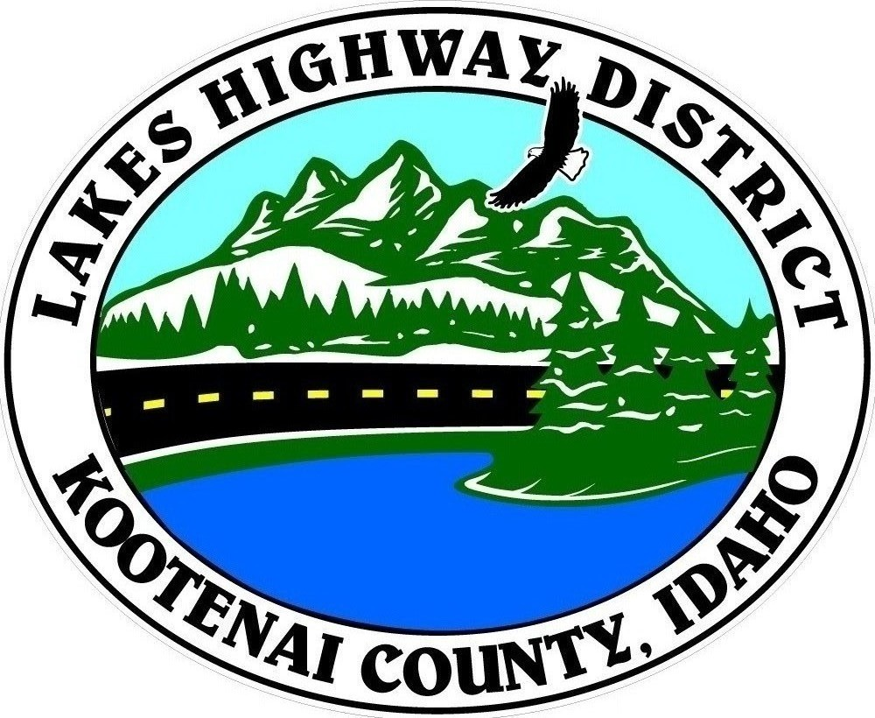
LAKES HIGHWAY DISTRICT
Chairman, Rodney A. Twete, Commissioner District 1
Vice Chairman, Weston E. “Monty” Montgomery, Commissioner District 2
Diane J. Fountain, Commissioner District 3

BOARD MEETING AGENDA

August 1, 2022, 2022 - 5:30 p.m.
11341 N. Ramsey Road
Hayden, Idaho 83835

1. Call Meeting to Order
2. Pledge of Allegiance
3. Approve August 1, 2022 Meeting Agenda (Action Item)
4. Approve July 18, 2022 Regular Meeting Minutes (Action Item)
5. Approve July 20, 2022 Special Meeting Minutes (Action Item)
6. Public Comment – this section is reserved for citizens wishing to address the Board regarding District related issue. Comments are limited to two (2) minutes per person. Idaho Law prohibits Board action on items brought under this section.

7. Old Business

8. Current Business
a. 2022-2023 Budget & Hearing Announcement (Action Item)
b. Daum Acres 2nd Addition Plat Review (Action Item)
c. Old Hwy 95 UPRR Bridge Project (Action Item)
d. Garwood Facility Consultant Contracts (Action Item)

9. Executive Session
a. Idaho Code §74-206 (1) (c) Right-of-Way Acquisition (Action Item)

10. Upcoming Meetings
a. Lakes Highway District Meeting – August 29, 2022 – 5:30 p.m.

11. Commissioner Comments

12. ADJOURN

Any person needing special accommodations to participate in the above noticed meeting should contact Lakes Highway District five (5) days prior to the meeting at (208)772-7527 or 11341 N. Ramsey Road, Hayden, Idaho 83835.

