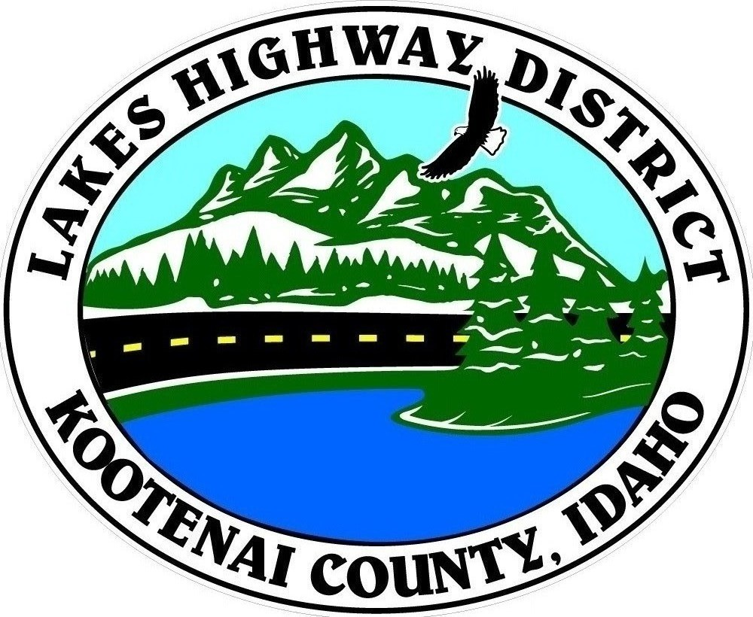
LAKES HIGHWAY DISTRICT
Chairman, Rodney A. Twete, Commissioner District 1
Vice Chairman, Weston E. “Monty” Montgomery, Commissioner District 2
Diane J. Fountain, Commissioner District 3

BOARD MEETING AGENDA
June 5, 2023 - 5:30 p.m.
11341 N. Ramsey Road
Hayden, Idaho 83835

1. Call Meeting to Order
2. Pledge of Allegiance
3. Approve June 5, 2023 Meeting Agenda (Action Item)
4. Approve May 1, 2023 Regular Meeting Minutes (Action Item)
5. Administrative Matters
a. Approve Financial Reports – (Action Item)
6. Public Comment – this section is reserved for citizens wishing to address the Board regarding District related issues. Comments are limited to two (2) minutes per person. Idaho Law prohibits Board action on items brought under this section.

7. Old Business
a. Cape Horn Road Retaining Wall (Action Item)
b. Garwood Facility (Action Item)

8. Current Business
a. Aubrey Estates Plat Review (Action Item)
b. DeLong Paradise Plat Review (Action Item)
c. Dodd Road Zone Change Request (Action Item)
d. Atlas Road Zone Change Request (Action Item)
e. Special Events Application – Bayview Daze Parade (Action Item)
f. Special Events Application – Spokane to Sandpoint Relay (Action Item)
g. 2023 LSHIP Grant Design Consultant Agreement (Key No 23284) (Action Item)
h. Part Time Employee Benefits (Discussion Item)
i. Employee Pay Increase (Action Item)

9. Executive Session
a. I.C. §74-206(1) (b) & (f) (Action Item)

10. Upcoming Meetings
a. Lakes Highway District Meeting – June 19, 2023 – 5:30 p.m.

11. Commissioner Comments

12. ADJOURN

Any person needing special accommodations to participate in the above noticed meeting should contact Lakes Highway District five (5) days prior to the meeting at (208)772-7527 or 11341 N. Ramsey Road, Hayden, Idaho 83835.

