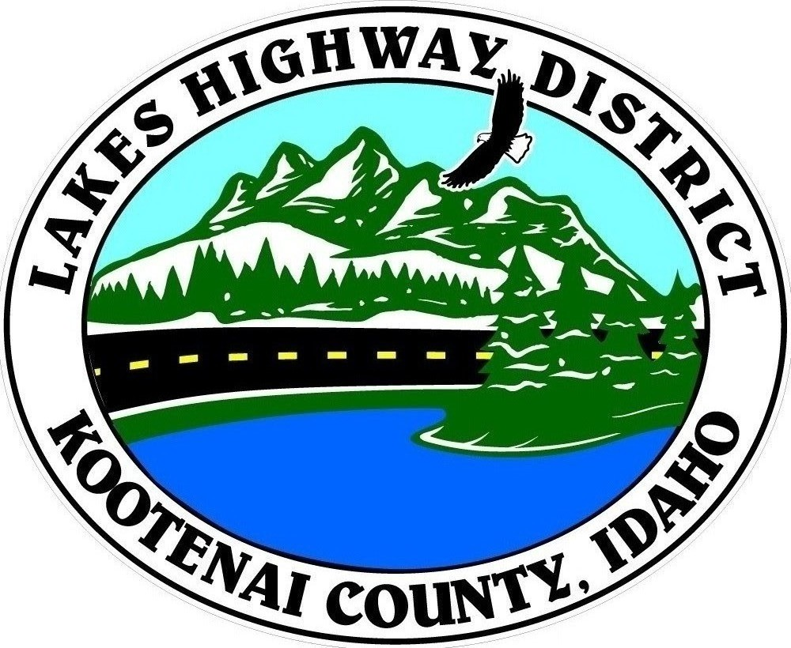
LAKES HIGHWAY DISTRICT
Chairman, Rodney A. Twete, Commissioner District 1
Vice Chairman, Weston E. “Monty” Montgomery, Commissioner District 2
Diane J. Fountain, Commissioner District 3

BOARD MEETING AGENDA

November 7, 2022, 2022 - 5:30 p.m.
11341 N. Ramsey Road
Hayden, Idaho 83835

1. Call Meeting to Order
2. Pledge of Allegiance
3. Approve November 7, 2022 Meeting Agenda (Action Item)
4. Approve October 17, Regular Meeting Minutes (Action Item)
5. Approve October 25, 2022 Special Meeting Minutes (Action Item)
6. Public Comment – this section is reserved for citizens wishing to address the Board regarding District related issue. Comments are limited to two (2) minutes per person. Idaho Law prohibits Board action on items brought under this section.

7. Old Business

8. Current Business
a. SPN22-0005 - ID Pur-Pose Special Permit Notice (Action Item)
b. Government Way Budget Reconciliation (Action Item)
c. Welch Comer Monument Agreement 2023 Construction Projects (Action Item)
d. Health Insurance Renewal (Action Item)
e. Employee VEBA Benefits (Action Item)
f. 550 Pickup Purchases (Action Item)

9. Executive Session
a. Idaho Code §74-206 (1) (a) District Employee

10. Upcoming Meetings
a. Lakes Highway District Meeting – November 21, 2022 – 5:30 p.m.

11. Commissioner Comments

12. ADJOURN

Any person needing special accommodations to participate in the above noticed meeting should contact Lakes Highway District five (5) days prior to the meeting at (208)772-7527 or 11341 N. Ramsey Road, Hayden, Idaho 83835.

