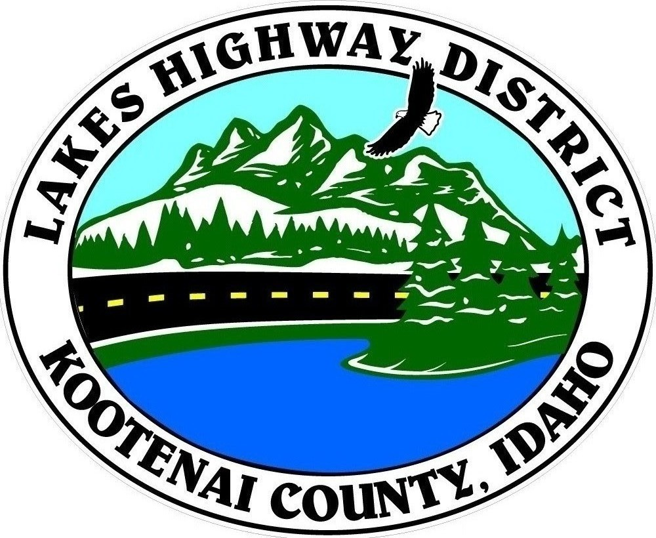
LAKES HIGHWAY DISTRICT
Chairman, Rodney A. Twete, Commissioner District 1
Vice Chairman, Weston E. “Monty” Montgomery, Commissioner District 2
Diane J. Fountain, Commissioner District 3

BOARD MEETING AGENDA

December 6, 2021 - 5:30 p.m.
11341 N. Ramsey Road
Hayden, Idaho 83835
1. Call Meeting to Order
2. Pledge of Allegiance
3. Approve December 6, 2021 Meeting Agenda (Action Item)
4. Approve November 15, 2021 Meeting Minutes (Action Item)
5. Approve November 17, 2021 Special Meeting Minutes (Action Item)
6. Administrative Matters
a. Approve Financial Reports – (Action Item)
7. Public Comment – this section is reserved for citizens wishing to address the Board regarding District related issue. Comments are limited to two (2) minutes per person. Idaho Law prohibits Board action on items brought under this section.
8. Old Business
9. Current Business
a. Old Hwy 95 Bridge Project Presentation David Evans & Assoc. (Action Item)
b. Pristine Pines Plat Review (Action Item)
c. Paw Paradise Plat Review (Action Item)
d. God’s Little Acres Plat Review Action Item)
e. Pacific Northwest Bridge Maintenance Conference (Action Item)
f. 2022 Meeting Schedule (Action Item)
g. Taxing District Election Form (Action Item)
h. City of Coeur d’Alene Annexation Request (Action Item)
i. Public Hearing – Pre-Development & Commercial Review Fees (Action Item)
j. Kenworth Truck(s) Purchase (Action Item)
k. Resolution 2021-09 Hoodoo Valley Fifth Addition Road Acceptance (Action Item)
l. Resolution 2021-10 Hoodoo Valley Sixth Addition Road Acceptance (Action Item)
m. Resolution 2021-11 Walking Horse Estates 1st Addition Road Acceptance (Action Item)
n. Resolution 2021-12 Lone Mountain Estates 5th Addition Road Acceptance (Action Item)
o. Resolution 2021-14 Pinewood Estates Road Acceptance (Action Item)
p. Pickup 33 Engine Replacement (Action Item)
q. Garwood Site Facility Needs Study (Action Item)
r. Accounting Software & Electronic Timekeeper (Action Item)
s. 2021 End of Year Report
10. Executive Session
a. Idaho Code 74-206 (1) (b) (Action Item)
b. Idaho Code 74-206 (1) (c) (Action Item)
11. Upcoming Meetings
a. Lakes Highway District Meeting – December 20, 2021
12. Commissioner Comments
13. ADJOURN
**DUE TO COVID 19 RESTRICTIONS, GATHERING SIZE TO BE IN ACCORDANCE WITH PANHANDLE HEALTH DISTRICT GUIDELINES. **
Any person needing special accommodations to participate in the above noticed meeting should contact Lakes Highway District five (5) days prior to the meeting at (208)772-7527 or 11341 N. Ramsey Road, Hayden, Idaho 83835.

