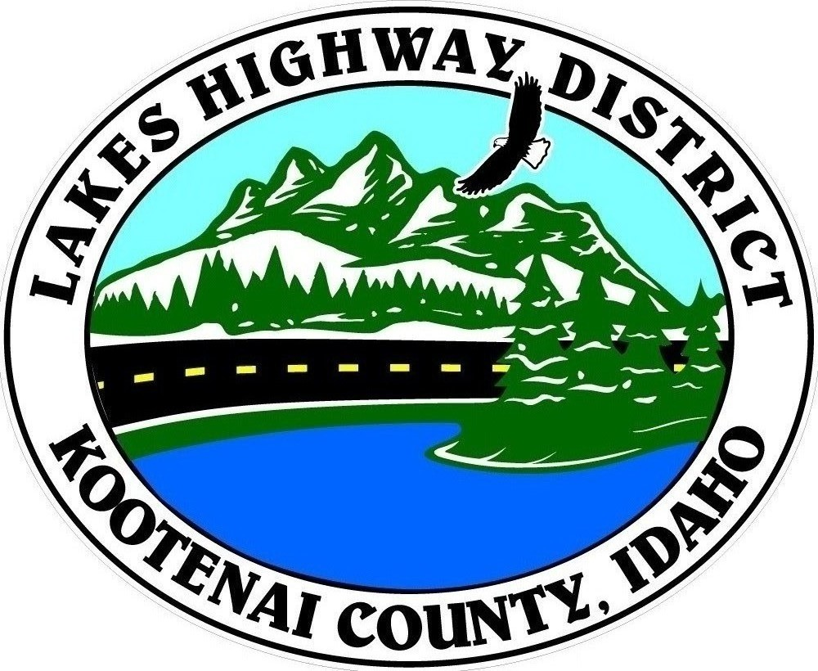
LAKES HIGHWAY DISTRICT
Chairman, Rodney A. Twete, Commissioner District 1
Vice Chairman, Weston E. “Monty” Montgomery, Commissioner District 2
Diane J. Fountain, Commissioner District 3

BOARD MEETING AGENDA

August 29, 2022 - 5:30 p.m.
11341 N. Ramsey Road
Hayden, Idaho 83835

1. Call Meeting to Order
2. Pledge of Allegiance
3. Approve August 29, 2022 Meeting Agenda (Action Item)
4. Approve August 1, 2022 Regular Meeting Minutes (Action Item)
5. Administrative Matters
a. Approve Financial Reports – (Action Item)
6. Public Comment – this section is reserved for citizens wishing to address the Board regarding District related issue. Comments are limited to two (2) minutes per person. Idaho Law prohibits Board action on items brought under this section.
7. Old Business
a. Reconvene Public Hearing – Validation of Viewer Report #30 (Action Item)
8. Current Business
a. Public Hearing – FY 2022-2023 Budget (Action Item)
b. Kootenai County’s Late Penalties & Interest (Action Item)
c. Kootenai County Bonded Indebtedness Form (Action Item)
d. Special Events Application – Hayden Lake Marathon (Action Item)
e. Rob Roi Plat Review (Action Item)
f. Buck N’Rail Plat Review (Action Item)
g. Lakeland Meadows 3rd Addn Plat Review (Action Item)
h. Caterpillar 420 Backhoe Purchase (Action Item)
i. Set Public Hearing – Validation of Red Spire Road (Action Item)
j. Resolution 2022-05 Fox Hollow 1st Addition Road Acceptance (Action Item)
k. Final Balancing Change Order – 2022 Construction Projects (Action Item)
l. Final Pay Request for Interstate Concrete & Asphalt–2022 Projects (Action Item)
9. Executive Session
a. Idaho Code §74-206 (1) (c), (f) & (i)
10. Upcoming Meetings
a. Lakes Highway District Meeting – September 19, 2022 – 5:30 p.m.
11. Commissioner Comments
12. ADJOURN

Any person needing special accommodations to participate in the above noticed meeting should contact Lakes Highway District five (5) days prior to the meeting at (208)772-7527 or 11341 N. Ramsey Road, Hayden, Idaho 83835.

