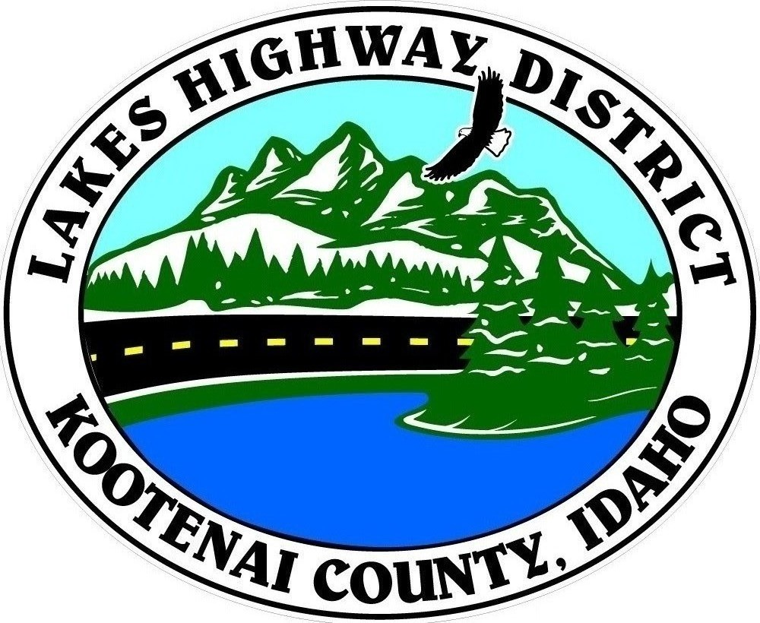
LAKES HIGHWAY DISTRICT
Chairman, Rodney A. Twete, Commissioner District 1
Vice Chairman, Weston E. “Monty” Montgomery, Commissioner District 2
Diane J. Fountain, Commissioner District 3

BOARD MEETING AGENDA

June 19, 2023 - 5:30 p.m.
11341 N. Ramsey Road
Hayden, Idaho 83835

1. Call Meeting to Order
2. Pledge of Allegiance
3. Approve June 19, 2023 Meeting Agenda (Action Item)
4. Approve June 5, 2023, Regular Meeting Minutes (Action Item)
5. Approve June 8, 2023, Special Meeting Minutes (Action Item)
6. Administrative Matters
a. Approve Financial Reports – (Action Item)
7. Public Comment – this section is reserved for citizens wishing to address the Board regarding District related issues. Comments are limited to two (2) minutes per person. Idaho Law prohibits Board action on items brought under this section.

8. Old Business
a. Garwood Facility (Action Item)

9. Current Business
a. Sloan Acres Plat Review (Action Item)
b. Timberland Ranch Plat Review (Action Item)
c. Viper Rental Dodd Road Zone Change Request (Action Item)

10. Executive Session
a. I.C. §74-206(1) (b) (Action Item)

11. Upcoming Meetings
a. Lakes Highway District Meeting – July 3, 2023 – 5:30 p.m.

12. Commissioner Comments

13. ADJOURN

Any person needing special accommodation to participate in the above noticed meeting should contact Lakes Highway District five (5) days prior to the meeting at (208)772-7527 or 11341 N. Ramsey Road, Hayden, Idaho 83835.

