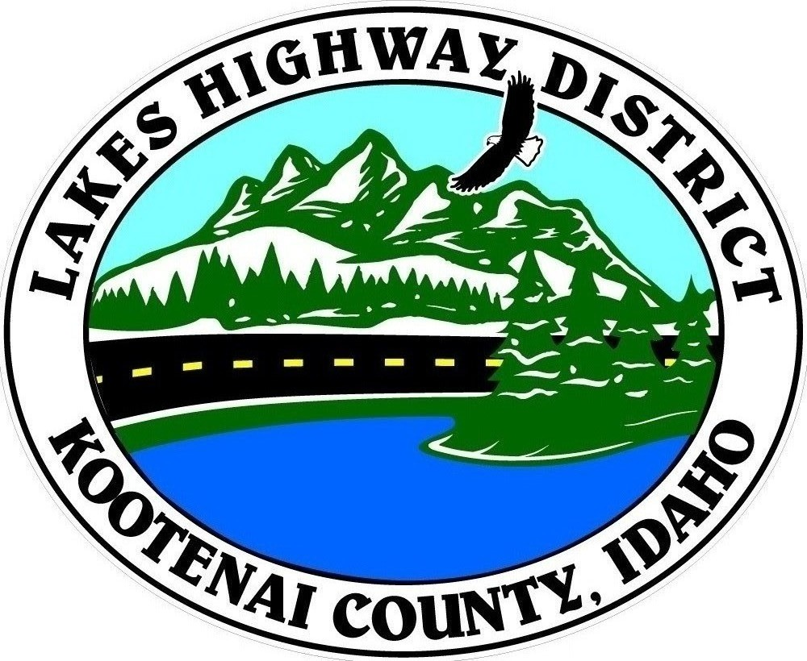
LAKES HIGHWAY DISTRICT
Chairman, Rodney A. Twete, Commissioner District 1
Vice Chairman, Weston E. “Monty” Montgomery, Commissioner District 2
Diane J. Fountain, Commissioner District 3

BOARD MEETING AGENDA

May 15, 2023, - 5:30 p.m.
11341 N. Ramsey Road
Hayden, Idaho 83835

DUE TO LACK OF AGENDA ITEMS, THE MAY 15, 2023 REGULAR SCHEDULED MEETING OF THE LAKES HIGHWAY DISTRICT BOARD OF COMMISSIONERS HAS BEEN CANCELLED.

THE NEXT REGULAR BOARD MEETING IS JUNE 5, 2023 AT 5:30 P.M.

