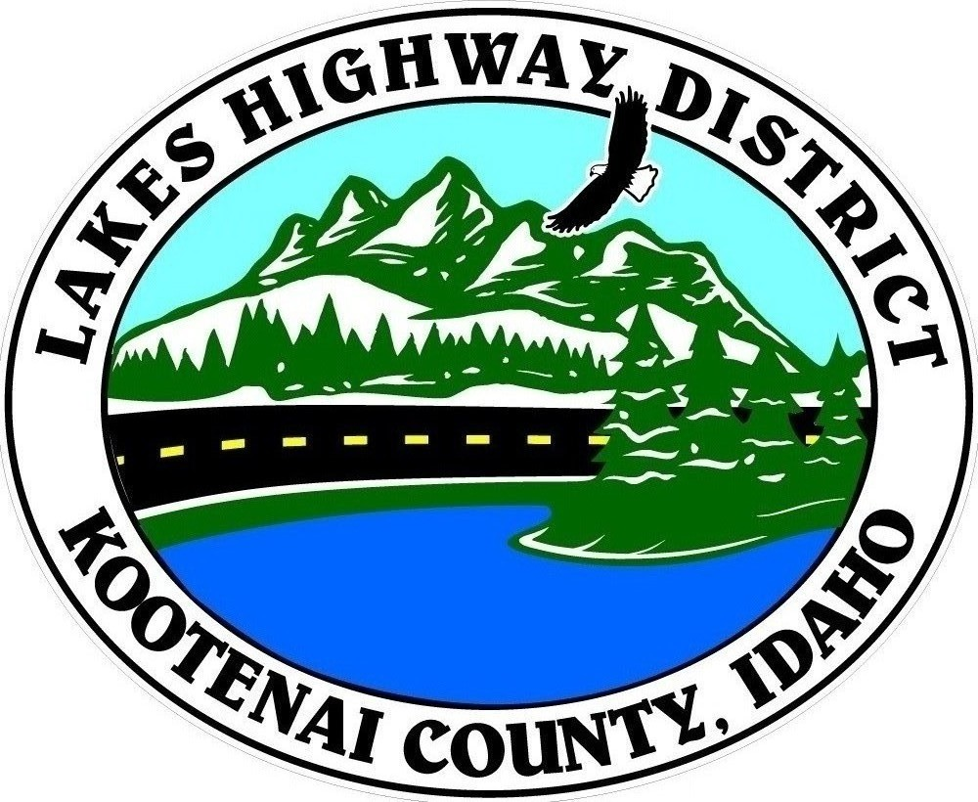
LAKES HIGHWAY DISTRICT
Chairman, Rodney A. Twete, Commissioner District 1
Vice Chairman, Weston E. “Monty” Montgomery, Commissioner District 2
Diane J. Fountain, Commissioner District 3

BOARD MEETING AGENDA

May 16, 2022 - 5:30 p.m.
11341 N. Ramsey Road
Hayden, Idaho 83835

1. Call Meeting to Order
2. Pledge of Allegiance
3. Approve May 16, 2022 Meeting Agenda (Action Item)
4. Approve April 18, 2022 Regular Meeting Minutes (Action Item)
5. Administrative Matters
a. Approve Financial Reports – (Action Item)
6. Public Comment – this section is reserved for citizens wishing to address the Board regarding District related issue. Comments are limited to two (2) minutes per person. Idaho Law prohibits Board action on items brought under this section.
7. Old Business
a. Reconvene Public Hearing – Validation of Viewer Report #30 (Action Item)
8. Current Business
a. Dolan’s Deal Construction Plan Approval (Action Item)
b. Humbird Estates Revised Construction Plans (Action Item)
c. Prairie Avenue Development & Median Const. Plan Review (Action Item)
d. Jet’s Landing Plat Review (Action Item)
e. Tormozov Estates Plat Review (Action Item)
f. Variance Request Hudson Bay Road (Action Item)
g. On Call Surveying Agreement (Action Item)
h. Diagonal Road - Welch Comer Agreement Amendment No. 1 (Action Item)
i. UPRR Bridge Replacement Public Hearing Update
j. Cape Horn Guardrail Project Update

9. Executive Session
a. Idaho Code §74-206 (1) (f)
10. Upcoming Meetings
a. Lakes Highway District Meeting – June 6, 2022 – 5:30 p.m.
11. Commissioner Comments
12. ADJOURN

Any person needing special accommodations to participate in the above noticed meeting should contact Lakes Highway District five (5) days prior to the meeting at (208)772-7527 or 11341 N. Ramsey Road, Hayden, Idaho 83835.

