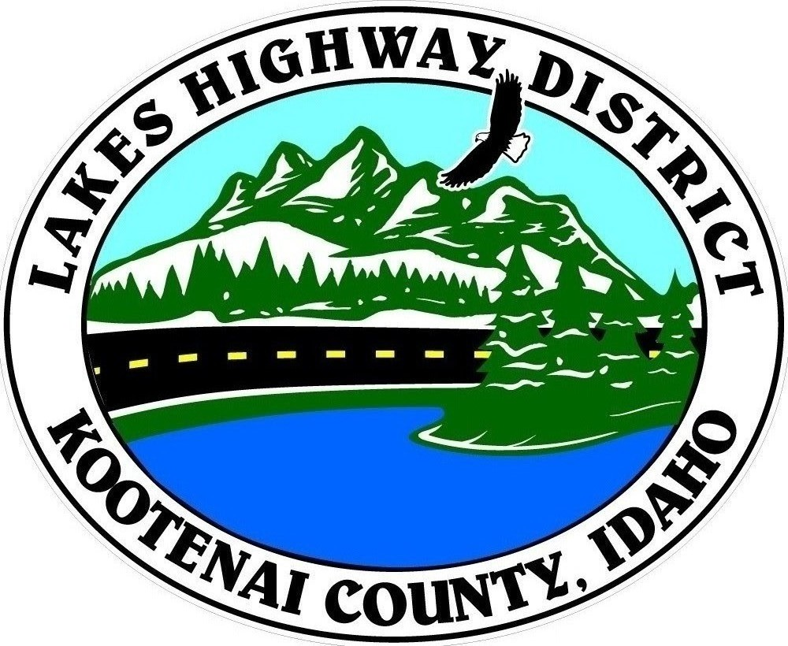
LAKES HIGHWAY DISTRICT
Chairman, Rodney A. Twete, Commissioner District 1
Vice Chairman, Weston E. “Monty” Montgomery, Commissioner District 2
Diane J. Fountain, Commissioner District 3

BOARD MEETING AGENDA

February 6, 2023 - 5:30 p.m.
11341 N. Ramsey Road
Hayden, Idaho 83835

1. Call Meeting to Order
2. Pledge of Allegiance
3. Approve February 6, 2023 Meeting Agenda (Action Item)
4. Approve January 23, 2023 Regular Meeting Minutes (Action Item)
5. Public Comment – this section is reserved for citizens wishing to address the Board regarding District related issue. Comments are limited to two (2) minutes per person. Idaho Law prohibits Board action on items brought under this section.

6. Old Business
a.
b.
7. Current Business
a. 2023 Construction Plan Approval & Call for Bids (Action Item)
b. Nettleton Gulch Forest Service Road Agreement (Action Item)
c. Set Public Hearing for Surplus Equipment (Action Item)
d.

8. Executive Session
a. Idaho Code 74-206 (1) (a)
9. Upcoming Meetings
a. Lakes Highway District Meeting – February 20, 2023 – 5:30 p.m.
10. Commissioner Comments
11. ADJOURN

Any person needing special accommodations to participate in the above noticed meeting should contact Lakes Highway District five (5) days prior to the meeting at (208)772-7527 or 11341 N. Ramsey Road, Hayden, Idaho 83835.

