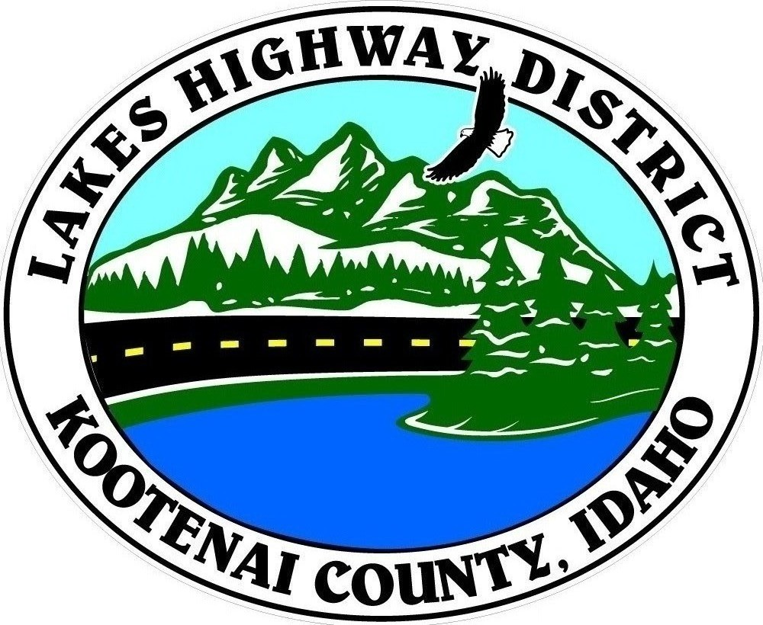
LAKES HIGHWAY DISTRICT
Chairman, Rodney A. Twete, Commissioner District 1
Vice Chairman, Weston E. “Monty” Montgomery, Commissioner District 2
Diane J. Fountain, Commissioner District 3

BOARD MEETING AGENDA

December 19, 2022 - 5:30 p.m.
11341 N. Ramsey Road
Hayden, Idaho 83835

1. Call Meeting to Order
2. Pledge of Allegiance
3. Approve December 19, 2022 Meeting Agenda (Action Item)
4. Approve November 21, 2022 Regular Meeting Minutes (Action Item)
5. Approve November 29, 2022 Special Meeting Minutes (Action Item)
6. Administrative Matters
a. Approve Financial Reports (Action Item)
7. Public Comment – this section is reserved for citizens wishing to address the Board regarding District related issue. Comments are limited to two (2) minutes per person. Idaho Law prohibits Board action on items brought under this section.

8. Old Business
a. Re-Convene Public Hearing – Spokane Valley Commercial Orchards (Action Item)

9. Current Business
- Public Hearing – Redspire Road Validation & Abandonment Petition (Action Item)
- Commissioner of the Year Award
- Day at the Capital (Action Item)
- Resolution 2022-05 – Lone Mountain Estates 6th Addition Road Acceptance (Action Item)
- Resolution 2022-06 – Hoodoo Valley North, Phase I Road Acceptance (Action Item)
- 2022 Local Road Mileage Report (Action Item)
- 2022 Street & Road Report (Action Item)
- Audit Engagement Letter (Action Item)
- CPA, Audit Support (Action Item)
- City of Hayden Transfer Agreement & Resolution (Action Item)
- Avondale Irrigation District Agreement Amendment(Action Item)

10. Executive Session
a. Idaho Code §74-206 (1) (b) & (c)

11. Upcoming Meetings
a. Lakes Highway District Meeting – January 9, 2023 – 5:30 p.m.

12. Commissioner Comments

13. ADJOURN

Any person needing special accommodations to participate in the above noticed meeting should contact Lakes Highway District five (5) days prior to the meeting at (208)772-7527 or 11341 N. Ramsey Road, Hayden, Idaho 83835.

