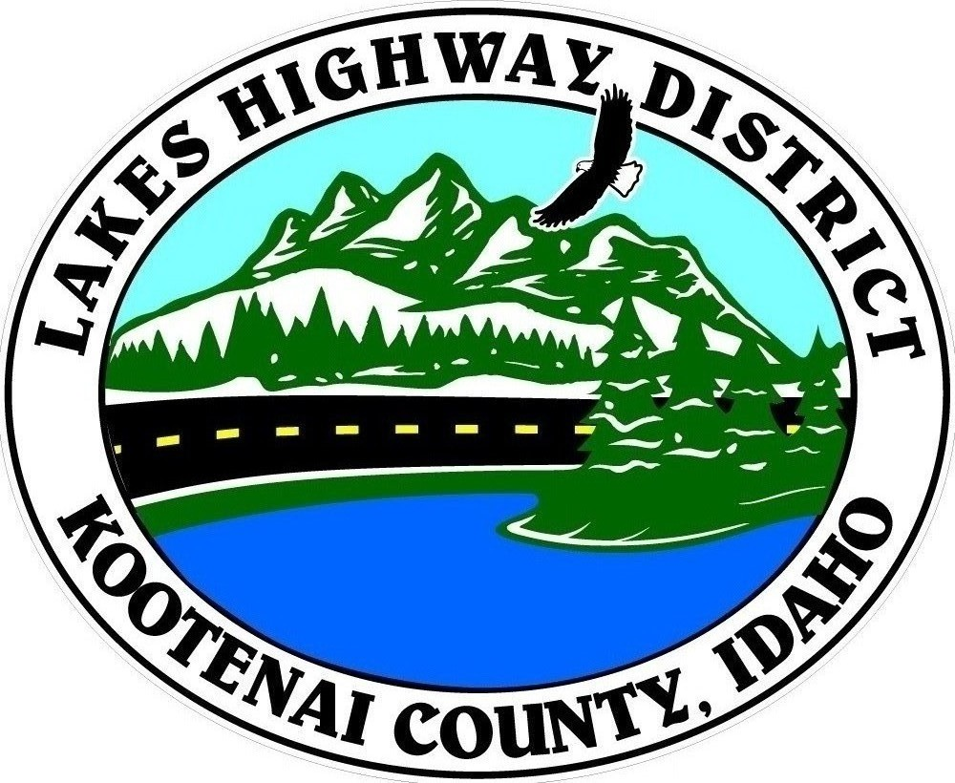
LAKES HIGHWAY DISTRICT
Chairman, Rodney A. Twete, Commissioner District 1
Vice Chairman, Weston E. “Monty” Montgomery, Commissioner District 2
Diane J. Fountain, Commissioner District 3

BOARD MEETING AGENDA

October 17, 2022, 2022 - 5:30 p.m.
11341 N. Ramsey Road
Hayden, Idaho 83835

1. Call Meeting to Order
2. Pledge of Allegiance
3. Approve October 17, 2022 Meeting Agenda (Action Item)
4. Approve October 3, 2022, Regular Meeting Minutes (Action Item)
5. Administrative Matters
a. Approve Financial Reports – (Action Item)
6. Public Comment – this section is reserved for citizens wishing to address the Board regarding District related issue. Comments are limited to two (2) minutes per person. Idaho Law prohibits Board action on items brought under this section.

7. Old Business

8. Current Business
a. Set Public Hearing – Abandonment & Vacation – Lake Park Acre Tracts (Action Item)
b. War Eagle Subdivision Plat Review – (Action Item)
c. Rivendell Subdivision Plat Review – (Action Item)
d. Parks Road Functional Classification (Action Item)
e. Re-Schedule Validation Public Hearing – Redspire (Action Item)

9. Executive Session
a. Idaho Code §74-206 (1) (a) District Employee
109. Upcoming Meetings
a. Lakes Highway District Meeting – November 7, 2022 – 5:30 p.m.

11. Commissioner Comments

12. ADJOURN

Any person needing special accommodations to participate in the above noticed meeting should contact Lakes Highway District five (5) days prior to the meeting at (208)772-7527 or 11341 N. Ramsey Road, Hayden, Idaho 83835.

