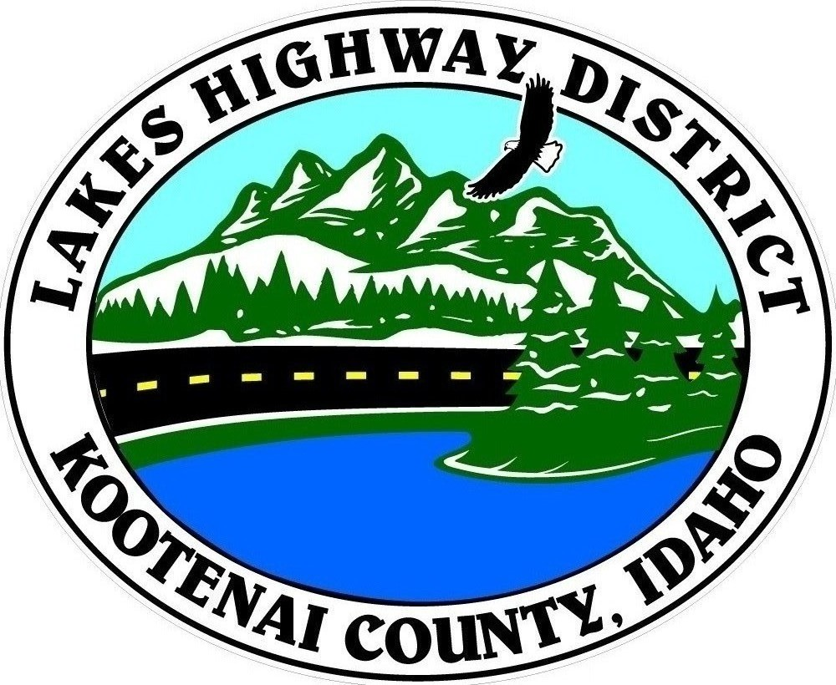
LAKES HIGHWAY DISTRICT
Chairman, Rodney A. Twete, Commissioner District 1
Weston E. “Monty” Montgomery, Commissioner District 2
Vice Chairman, Steven R. Adams, Commissioner District 3

BOARD MEETING AGENDA
November 20, 2023 - 5:30 p.m.
11341 N. Ramsey Road
Hayden, Idaho 83835

1. Call Meeting to Order
2. Pledge of Allegiance
3. Approve November 20, 2023 Meeting Agenda (Action Item)
4. Public Comment – this section is reserved for citizens wishing to address the Board regarding District related issues. Comments are limited to two (2) minutes per person. Idaho Law prohibits Board action on items brought under this section.

5. Consent Agenda (Action Item)
a. November 6, 2023 Regular Meeting Minutes
b. October 2023 Financial Reports
c. 2022-23 Financial Statement

6. Old Business –
a. Garwood Operations Facility (Action Item)
a.1 Interagency Exemption Agreement
b.1.1 Executive Session, Idaho Code §74-206 (1) (f) & (i) (Action Item)
a.2 Fire Suppression System
b.2.1 Executive Session, Idaho Code §74-206 (1) (f) & (i) (Action Item)
a.3 North Parcel Power Service
a.4 Pole Building Roof Structures
a.5 HMH Contract for Materials Testing

7. Current Business
a. 2023 SWMP/MS4 Joint Annual Report (Action Item)
b. Public Hearing – Lancaster Knob (Action Item)
c. 2024 Meeting Calendar (Action Item)
d. Govt Way and Pope Rd Speed Study Analysis (Action Item)
e. MIN23-0035 Mecham Pines Plat Review (Action Item)
f. CUP23-0008 Athol Baptist Church Review (Action Item)
g. Taxing District Election Form (Action Item)
h. Award of Surplus Equipment (Action Item)

8. Executive Session (Action Items)
a. Items 6.b.1 & 2, Garwood Operations Facility IC §74-206 (1) (f) & (i) (Action Item)

9. Upcoming Meetings
a. Lakes Highway District Meeting – December 4, 2023 – 5:30 p.m.

10. Commissioner Comments

11. ADJOURN

Any person needing special accommodations to participate in the above noticed meeting should contact Lakes Highway District five (5) days prior to the meeting at (208)772-7527 or 11341 N. Ramsey Road, Hayden, Idaho 83835.

