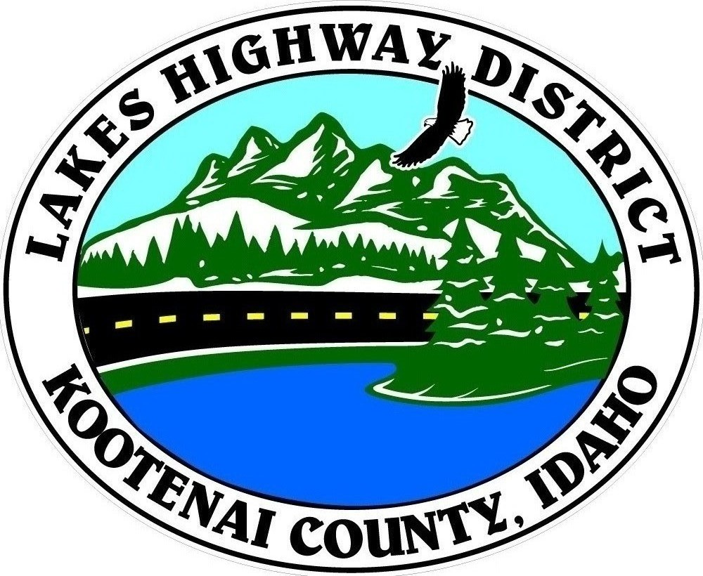
LAKES HIGHWAY DISTRICT
Chairman, Rodney A. Twete, Commissioner District 1
Vice Chairman, Weston E. “Monty” Montgomery, Commissioner District 2
Diane Fountain, Commissioner District 3

WORKSHOP AGENDA
April 13, 2016 @ 2:00 p.m.
11341 N. Ramsey Road
Hayden, Idaho 83835

1. Old Business
a.
2. Current Business
a. FY2016-2017 Budget
b.
c.
3. Engineer/Director’s Report
a.
4. Other Business
a.
5. Commissioner Items
a.
6. Executive Session
a.

Any person needing special accommodations to participate in the above noticed workshop should contact Lakes Highway District five (5) days prior to the workshop at (208)772-7527 or 11341 N. Ramsey Road, Hayden, Idaho 83835.

POSTED: April 11, 2016 @ 12.20 p.m.

