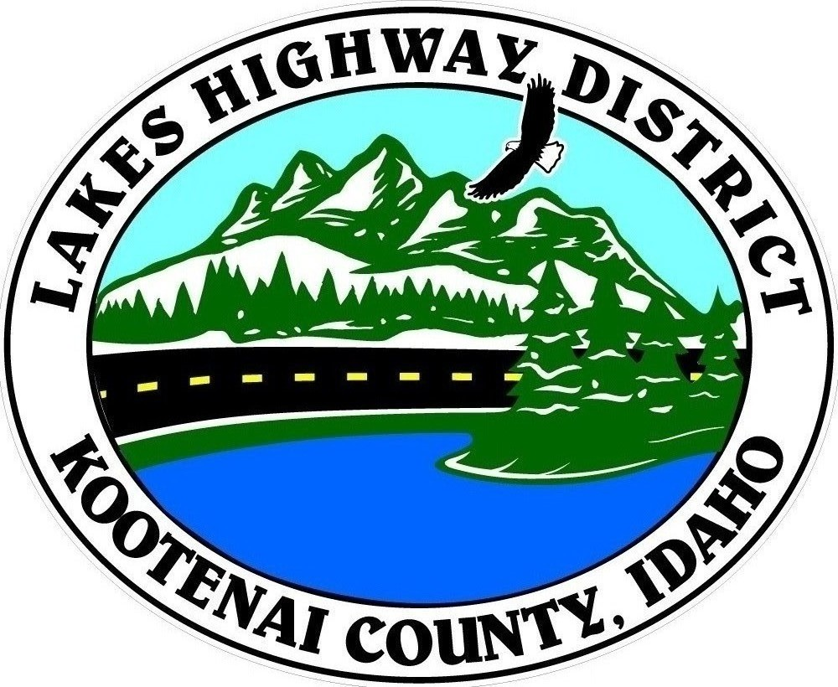
LAKES HIGHWAY DISTRICT
Chairman, Rodney A. Twete, Commissioner District 1
Vice Chairman, Weston E. “Monty” Montgomery, Commissioner District 2
Diane J. Fountain, Commissioner District 3

BOARD MEETING AGENDA

June 20, 2022 - 5:30 p.m.
11341 N. Ramsey Road
Hayden, Idaho 83835

1. Call Meeting to Order
2. Pledge of Allegiance
3. Approve June 20, 2022 Meeting Agenda (Action Item)
4. Approve June 6, 2022 Regular Meeting Minutes (Action Item)
5. Administrative Matters
a. Approve Financial Reports – (Action Item)
6. Public Comment – this section is reserved for citizens wishing to address the Board regarding District related issue. Comments are limited to two (2) minutes per person. Idaho Law prohibits Board action on items brought under this section.
7. Old Business
a.
8. Current Business
a. Special Permit Notice – Alpine Mini Storage (Action Item)
b. Survey Equipment – (Action Item)
c. Garwood Site Test Well Contract (Action Item)
d. Public Hearing – Abandonment & Vacation – Spruce Avenue (Action Item)
e. Special Events Application – Spokane to Sandpoint Relay Race (Action Item)

9. Executive Session
a.
10. Upcoming Meetings
a. Lakes Highway District Meeting – July 18,2022 – 5:30 p.m.
11. Commissioner Comments
12. ADJOURN

Any person needing special accommodations to participate in the above noticed meeting should contact Lakes Highway District five (5) days prior to the meeting at (208)772-7527 or 11341 N. Ramsey Road, Hayden, Idaho 83835.

