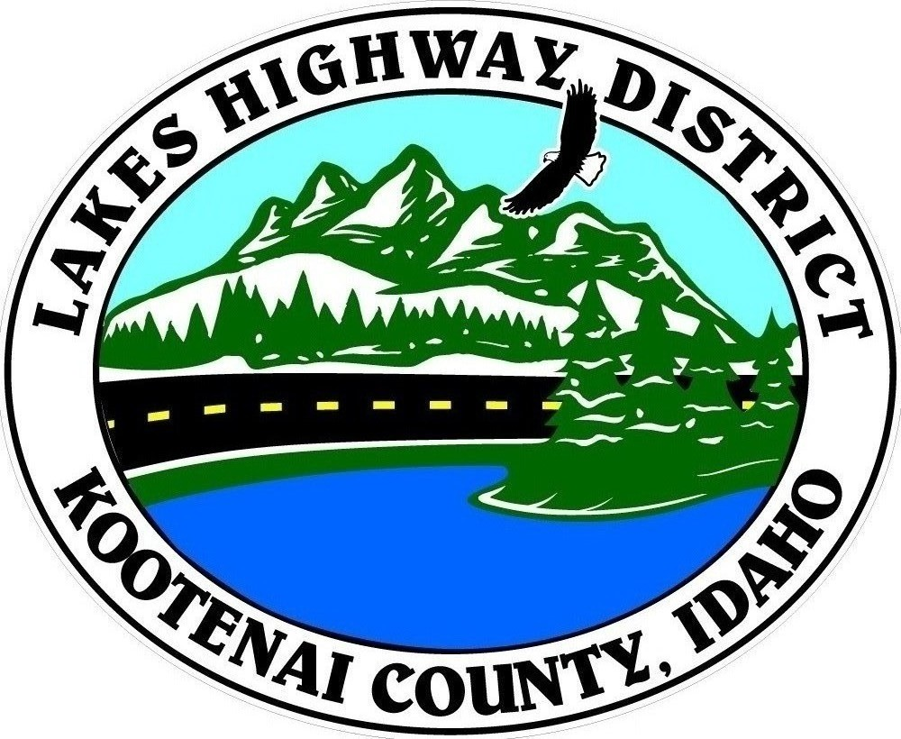
LAKES HIGHWAY DISTRICT
Chairman, Rodney A. Twete, Commissioner District 1
Vice Chairman, Weston E. “Monty” Montgomery, Commissioner District 2
Diane J. Fountain, Commissioner District 3

BOARD MEETING AGENDA

November 15, 2021 - 5:30 p.m.
11341 N. Ramsey Road
Hayden, Idaho 83835
1. Call Meeting to Order
2. Pledge of Allegiance
3. Approve November 15, 2021 Meeting Agenda (Action Item)
4. Approve November 1, 2021 Meeting Minutes (Action Item)
5. Administrative Matters
a. Approve Financial Reports – (Action Item)
6. Public Comment – this section is reserved for citizens wishing to address the Board regarding District related issue. Comments are limited to two (2) minutes per person. Idaho Law prohibits Board action on items brought under this section.
7. Old Business
a.
8. Current Business
a. Westwood Estates Proposed Major Subdivision
b. Howard Road Development Roads A & B (Action Item)
c. Dolans Deal 2nd Addition Plat Review (Action Item)
d. Adler Horst Plat Review (Action Item)
e. Painted Sky Estates Plat Review – (Action Item)
f. 2022 LHRIP Grant Application (Action Item)
g. FY2020-2021 Audit (Action Item)
h. 2020 NPDES/MS4 Annual Report (Action Item)
9. Executive Session
a. Idaho Code §74-206 (1) (a) Right-of-Way Acquisition (Action Item)
10. Upcoming Meetings
a. Lakes Highway District Meeting – December 6, 2021
11. Commissioner Comments

12. ADJOURN

**DUE TO COVID 19 RESTRICTIONS, GATHERING SIZE TO BE IN ACCORDANCE WITH PANHANDLE HEALTH DISTRICT GUIDELINES. **

Any person needing special accommodations to participate in the above noticed meeting should contact Lakes Highway District five (5) days prior to the meeting at (208)772-7527 or 11341 N. Ramsey Road, Hayden, Idaho 83835.

